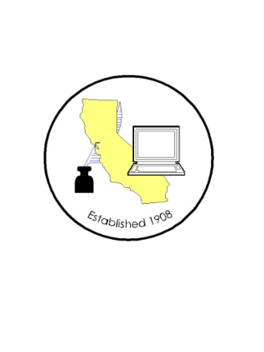

CALIFORNIA ASSOCIATION OF
CLERKS AND ELECTION OFFICIALS

TO: CACEO Members, Guests, Legislative Committee

FROM: Karen Rhea and Jill LaVine, Co-Chairs
Deborah Seiler, Honorary Chair

SUBJECT: CACEO LEGISLATIVE COMMITTEE MEETING

LOCATION: County of Sacramento
DTech, 799 G Street, 2nd Floor Conference Room
Sacramento, CA 95814

FRIDAY AGENDA – March 29, 2013

9 a.m. – 3 p.m.

Welcome and Introductions

Approval of March 8, 2013 minutes

9:15 a.m. - James Schwab, Legislative Consultant to Senator Padilla, SB 311, SB 360, SB 361, SB 362

Bills for Discussion:

AB 131 Williams (update)
AB 193 Logue (amended 2/14)
AB 214 Skinner (update)
AB 269 Grove (amended 3/14)
AB 301 Wagner (amended 3/11)
AB 331 Garcia (Tim and Stephanie to report)
AB 813 Melendez (amended 3/14)
AB 843 Logue bring back if amended
AB 1038 Pan
AB 1170 Donnelly requested to bring back
AB 1316 (Stephanie to report City Clerks’ position)
AB 1417 Committee bill (CACEO proposals 13-06 and 13-07)
AB 1418 Committee bill
AB 1419 Committee bill
SB 29 Correa (update)
SB 44 Yee (update)
SB 111 Beall (amended 3/6)
SB 112 Monning (amended 3/7, update)
SB 148 Anderson (amended 3/18)
SB 213 Galgiani (update)
SB 279 Hancock
SB 311 Padilla (Stephanie to report City Clerks’ position)
SB 360 Padilla
SB 361 Padilla (bring back for discussion)
SB 362 Padilla

